90 Days of Google Ads That Drove High-Quality Leads

ADS

Results that speak for themselves

Key Stats & Results


380%+ growth in form submissions after launching Google Ads

Scalable paid media foundation for long-term PI growth

Behind the transformation

How a PI Law Firm Scaled High-Quality Leads with Google Ads
A growing personal injury law firm partnered with Rankings.io to rebuild its paid media strategy from the ground up. In just 90 days, a newly launched Google Ads account began delivering consistent, high-quality personal injury leads with clear attribution and a dramatically improved cost per qualified lead, all while establishing a scalable foundation for long-term growth.

FROM CHALLANGES TO SUCCESS


The Challenge

This firm served multiple Western U.S. states and operated in highly competitive personal injury markets.
Before working with Rankings.io, their paid acquisition efforts struggled.
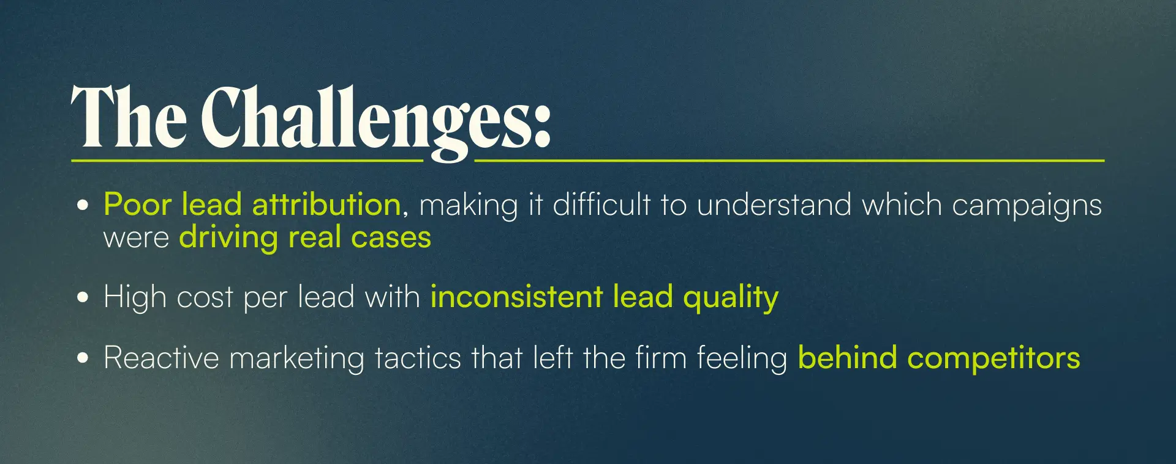
The firm needed a system built for data accuracy, qualified leads, and scalability.



How We Did It: The Strategy
Rankings.io launched a brand-new Google Ads account engineered specifically for personal injury lead generation.
Our approach prioritized: Precision targeting, conversion quality, and clean, reliable data from day one.

1. High-Intent Campaign Structure
We focused on bottom-of-funnel opportunities first:
- Low-funnel Google Search campaigns targeting high-commercial-intent PI keywords
- Carefully controlled Performance Max campaigns to expand reach without inflating CPCs in competitive motor vehicle accident markets
- A small, strategic YouTube test budget to support brand awareness and assisted conversions

2. Conversion Quality & Attribution Control
We built the entire account around qualified lead signals — not vanity metrics.
This included:
- Call tracking and qualification through CallRail
- High call-duration thresholds to filter out low-intent inquiries
- Frequent manual lead-quality reviews
- Tight negative keyword and exclusion controls
This allowed Google’s algorithm to optimize for real personal injury cases, not unqualified conversions.

3. Performance Max — Strategically Controlled
Instead of running Performance Max on autopilot, we:
- Segmented campaigns intentionally
- Actively managed CPC inflation
- Continuously audited lead quality
This ensured PMax supported search performance rather than diluting it.



Before & After
After just 90 days of a structured paid media rollout, our client achieved measurable gains across lead volume, quality, and efficiency.
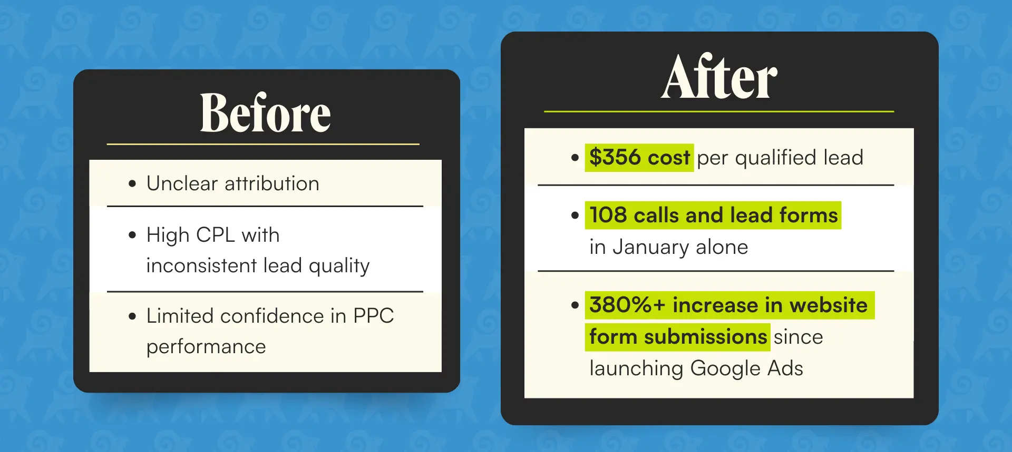

Key Wins
- $356 cost per qualified personal injury lead within 90 days
- 380%+ growth in form submissions after launching Google Ads
- Strong call volume (108 calls + forms) in just the second full month
- Clean attribution and conversion tracking built from day one
- Scalable paid media foundation for long-term PI growth

